Contents
1. One-time GCP setup 1
Service account the workflow will impersonate 2
SERVICE ACCOUNT EMAIL 3
Create Workload Identity Pool 3
Create Workload Identity Provider 4
Allow only THIS repo to impersonate the SA 5
Describe WorkLoad Identity Pool 6
GitHub repo settings 7
Workflow file 7
Now in GITHub Actions you will see Workflows: 8

1. One-time GCP setup
bash
PROJECT_ID="your-project-id"
PROJECT_NUMBER=$(gcloud projects describe $PROJECT_ID --format="value(projectNumber)")
REPO="pauriccarr/COEN6313"

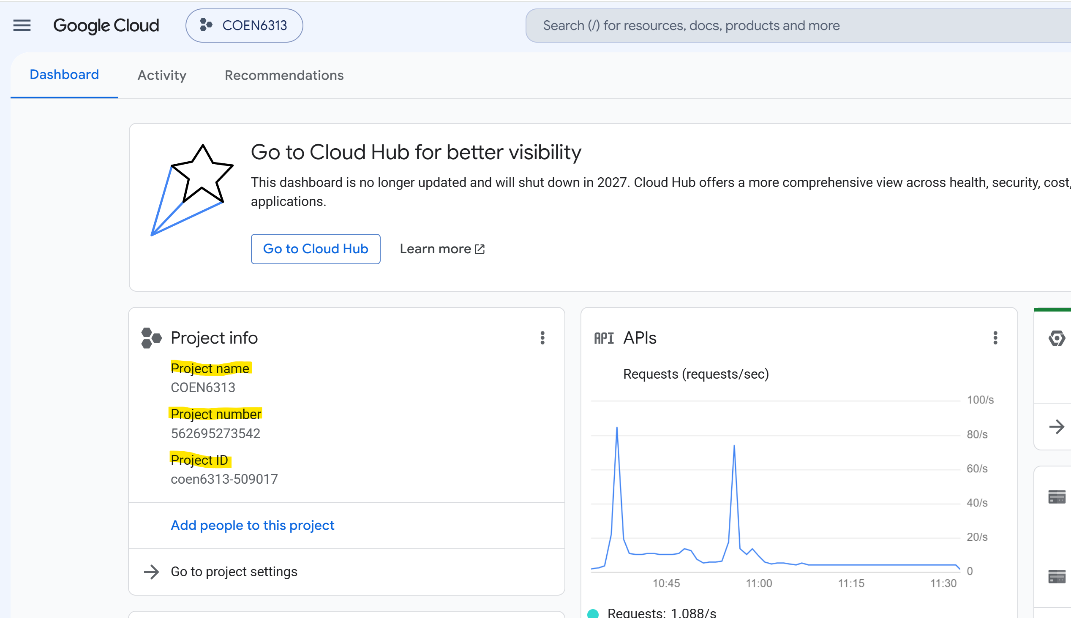
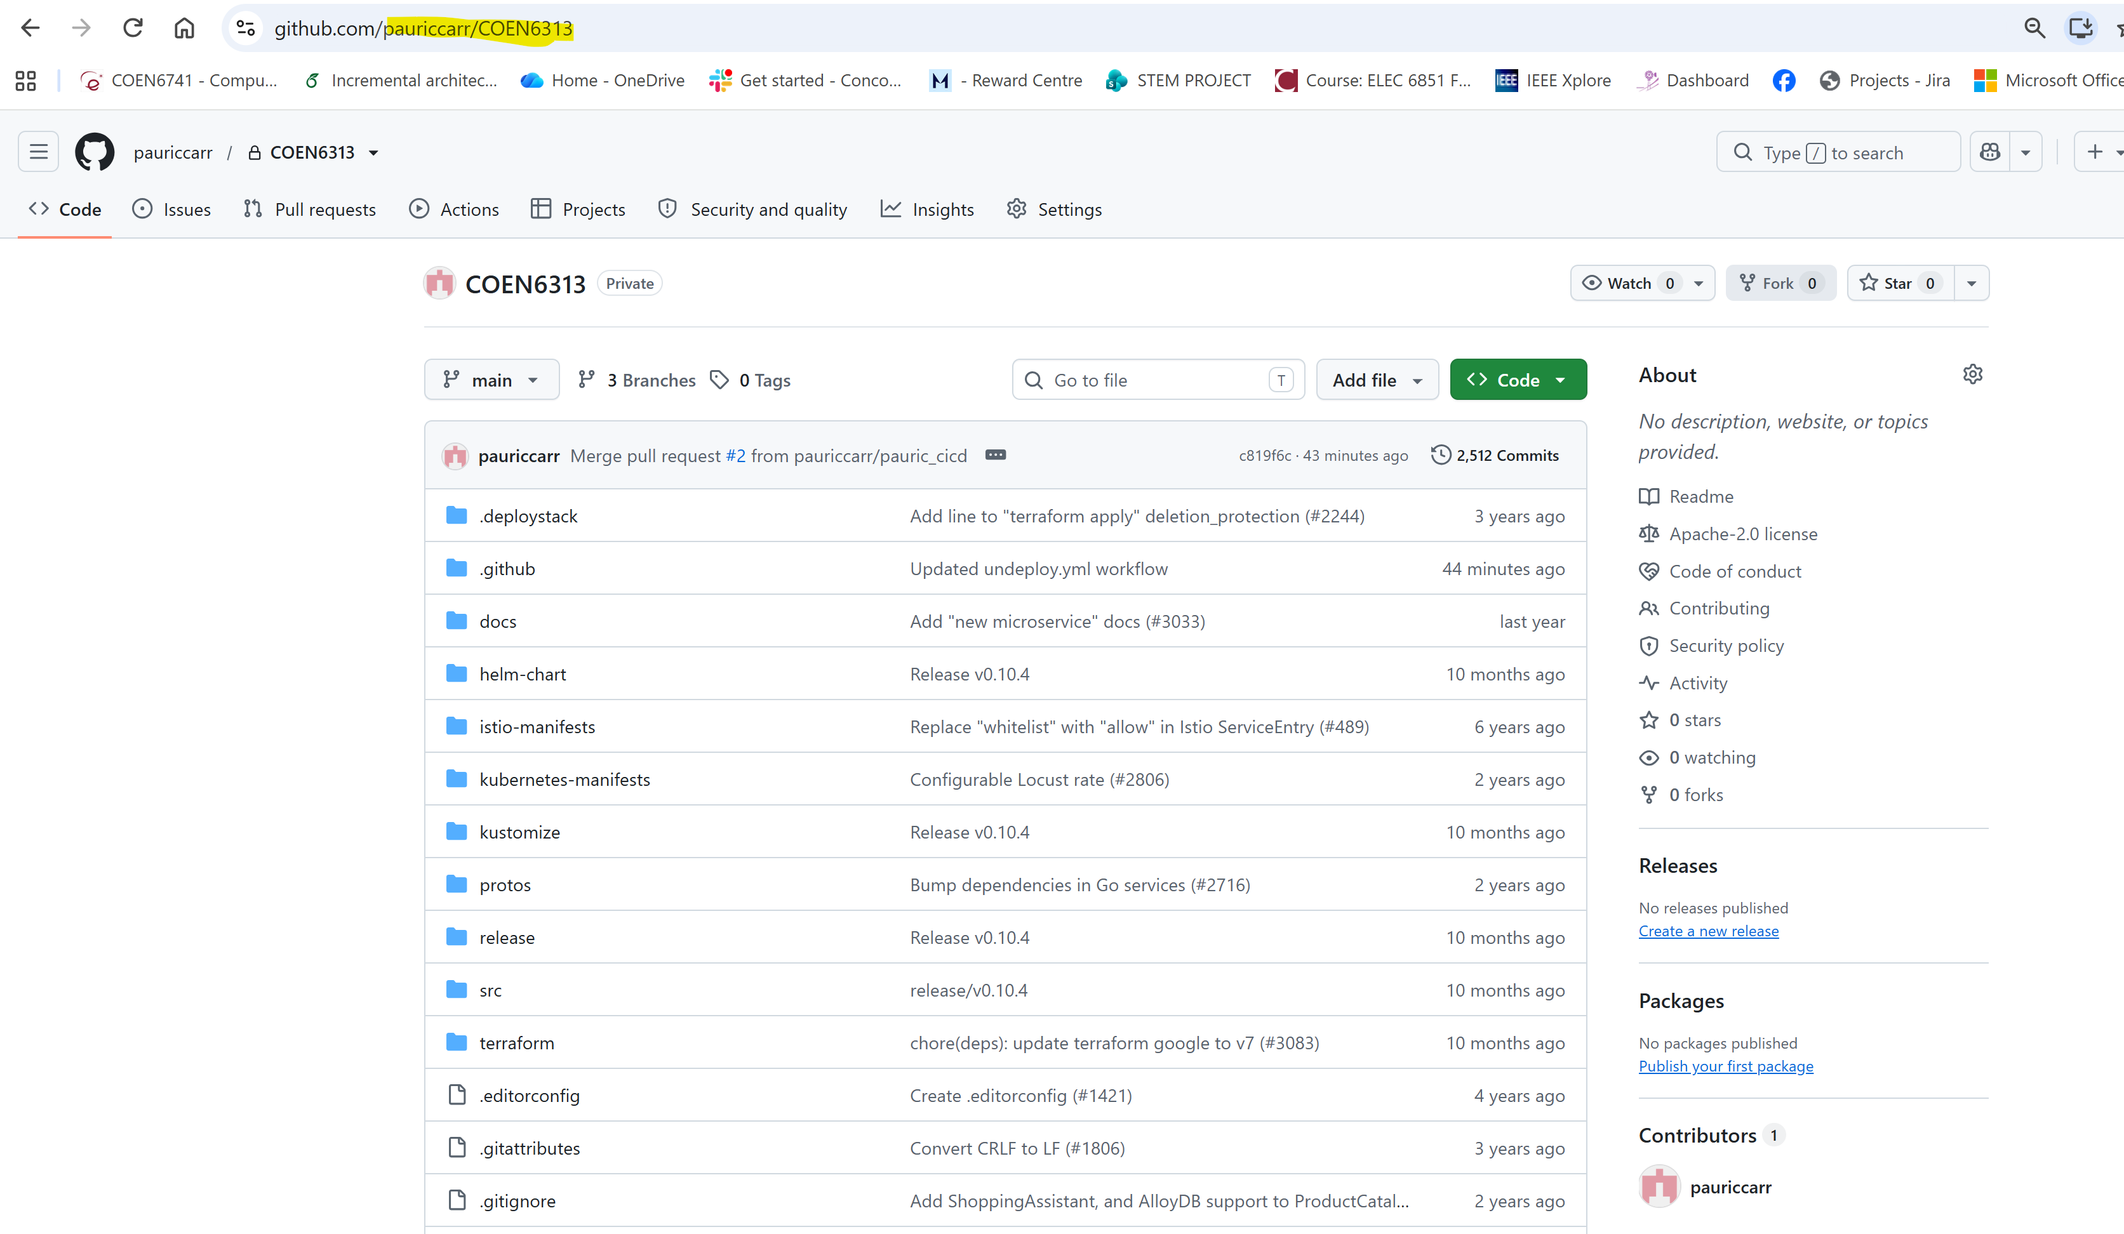

Service account the workflow will impersonate
gcloud iam service-accounts create github-deployer \
--project="$PROJECT_ID" \
--display-name="GitHub Actions GKE deployer"

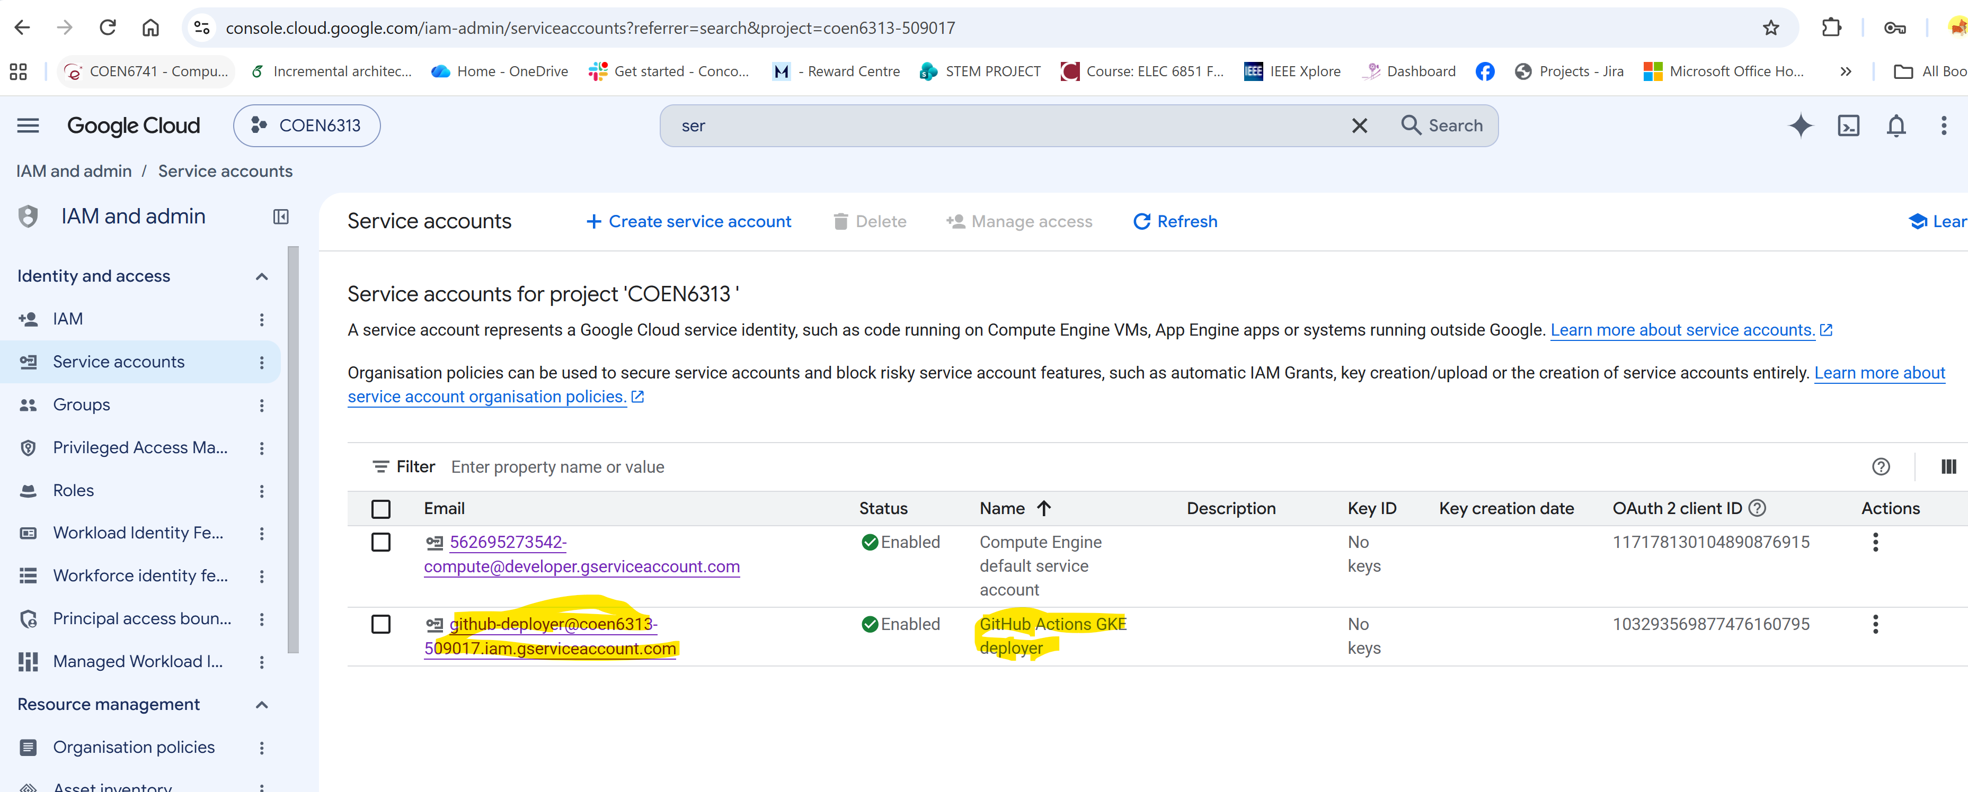

SERVICE ACCOUNT EMAIL
SA_EMAIL="github-deployer@${PROJECT_ID}.iam.gserviceaccount.com"
# Give it deploy rights on GKE (scope tighter to a namespace/RBAC role if you want less than this)
gcloud projects add-iam-policy-binding $PROJECT_ID \
--member="serviceAccount:${SA_EMAIL}" \
--role="roles/container.developer"

Create Workload Identity Pool
gcloud iam workload-identity-pools create "github-pool" \
--project="$PROJECT_ID" --location="global" \
--display-name="GitHub pool"

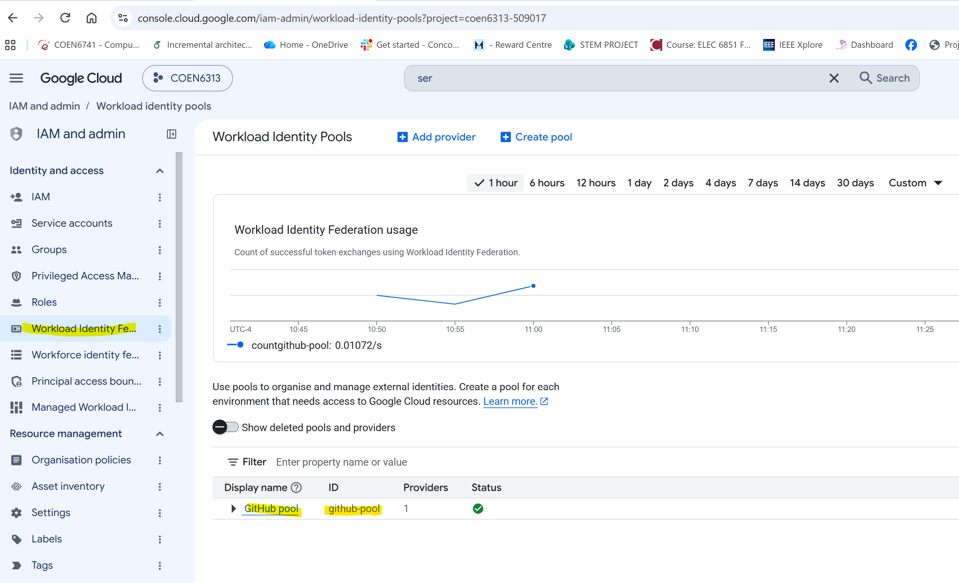

Create Workload Identity Provider

gcloud iam workload-identity-pools providers create-oidc "github-provider" \
--project="$PROJECT_ID" --location="global" \
--workload-identity-pool="github-pool" \
--display-name="GitHub" \
--attribute-mapping="google.subject=assertion.sub,attribute.repository=assertion.repository" \
--issuer-uri="https://token.actions.githubusercontent.com"

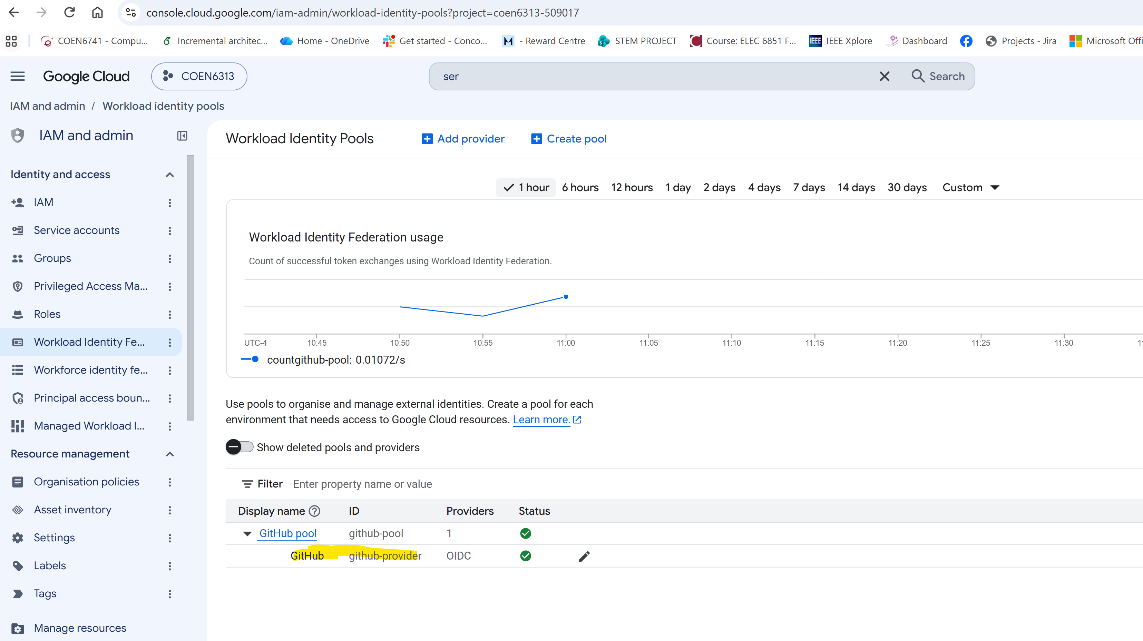

Allow only THIS repo to impersonate the SA
gcloud iam service-accounts add-iam-policy-binding "$SA_EMAIL" \
--project="$PROJECT_ID" \
--role="roles/iam.workloadIdentityUser" \
--member="principalSet://iam.googleapis.com/projects/${PROJECT_NUMBER}/locations/global/workloadIdentityPools/github-pool/attribute.repository/${REPO}"

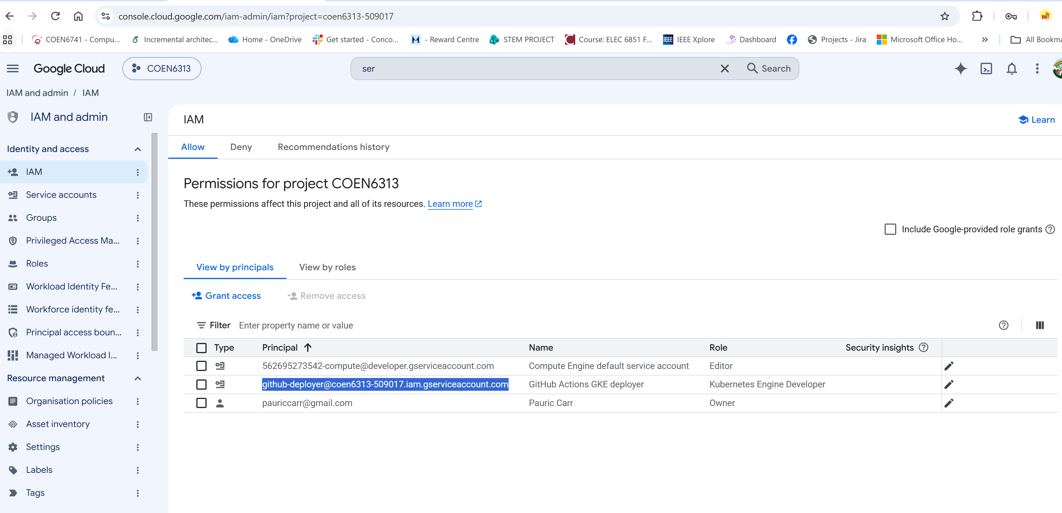
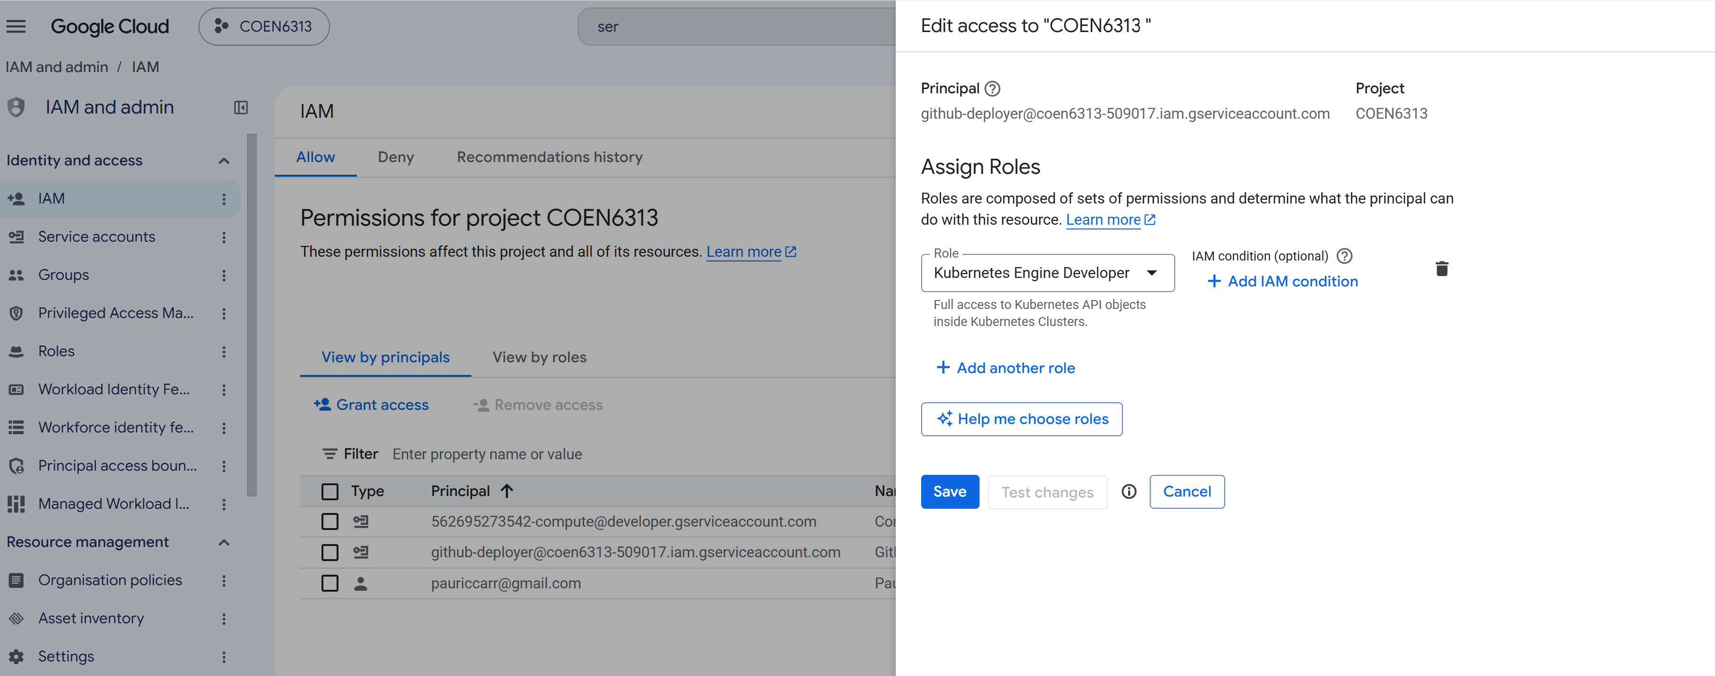

Describe WorkLoad Identity Pool

gcloud iam workload-identity-pools providers describe "github-provider" \
--project="$PROJECT_ID" --location="global" \
--workload-identity-pool="github-pool" --format="value(name)"

GitHub repo settings
Add these as repo secrets/variables (Settings → Secrets and variables → Actions):
- GCP_WORKLOAD_IDENTITY_PROVIDER — the full resource name from above
- GCP_SERVICE_ACCOUNT — github-deployer@your-project-id.iam.gserviceaccount.com
- GKE_CLUSTER — cluster name
- GKE_REGION — e.g. us-central1 (or GKE_ZONE if zonal)
- GCP_PROJECT_ID — your project ID

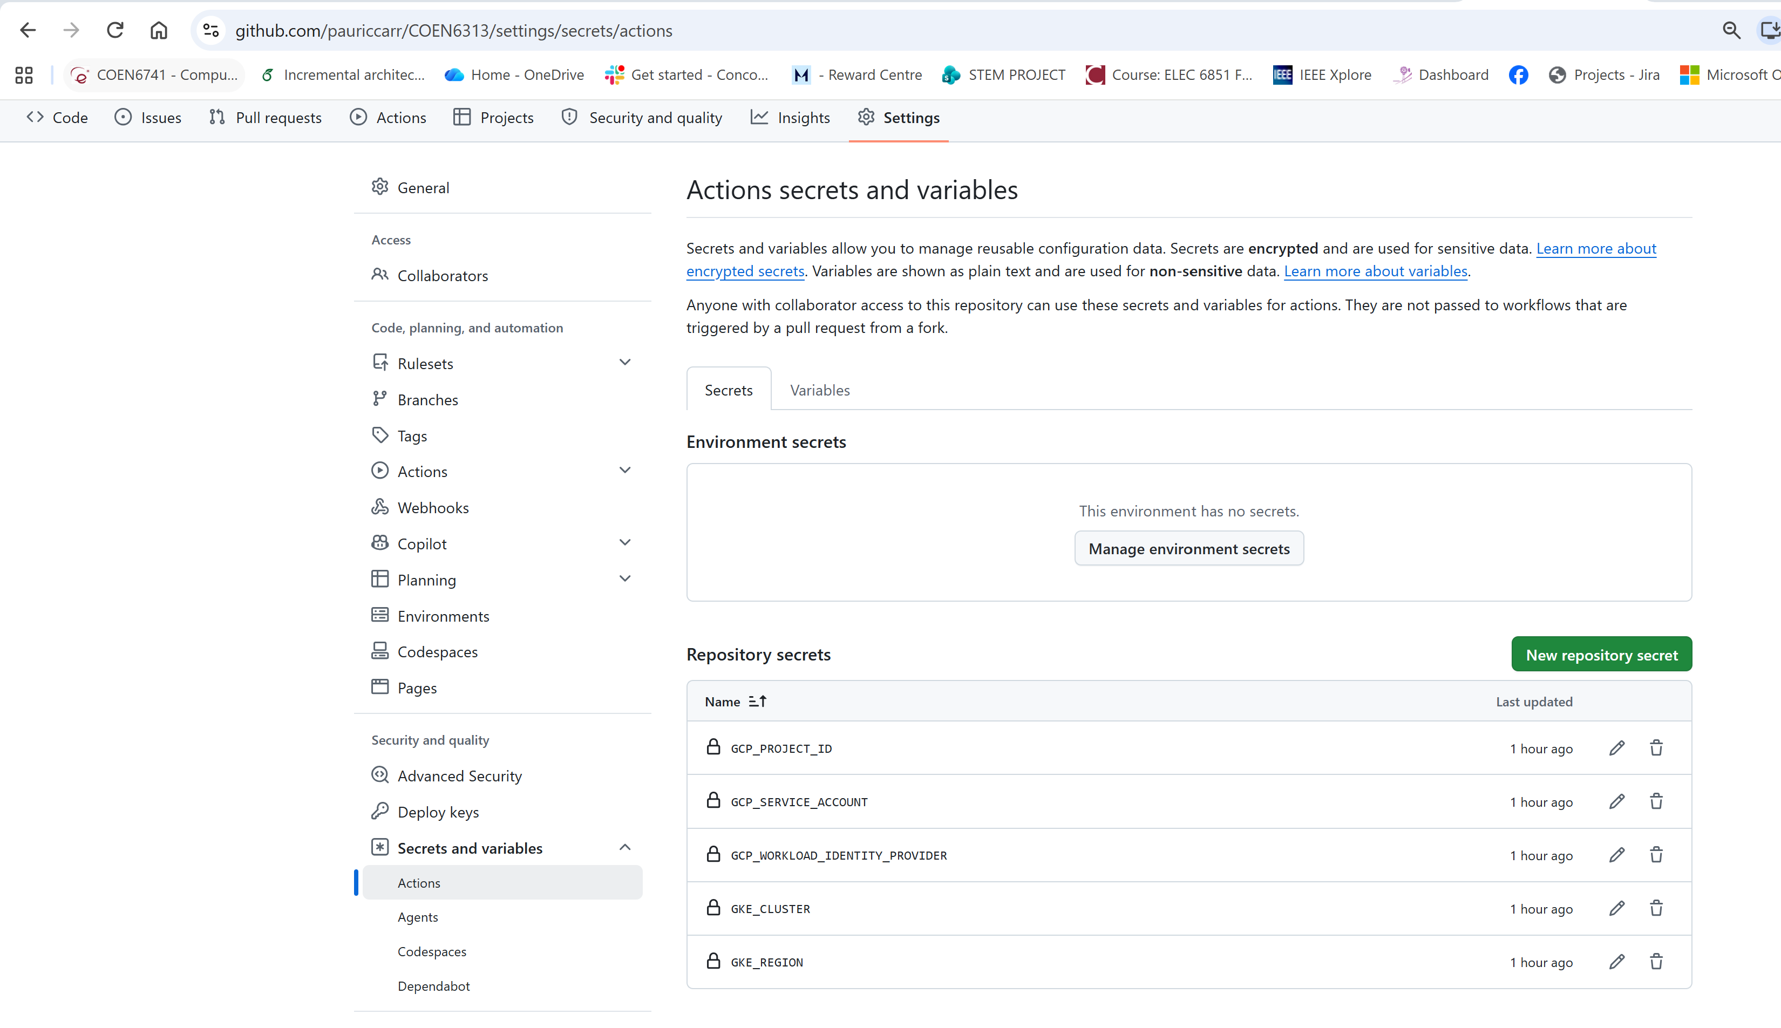

Workflow file

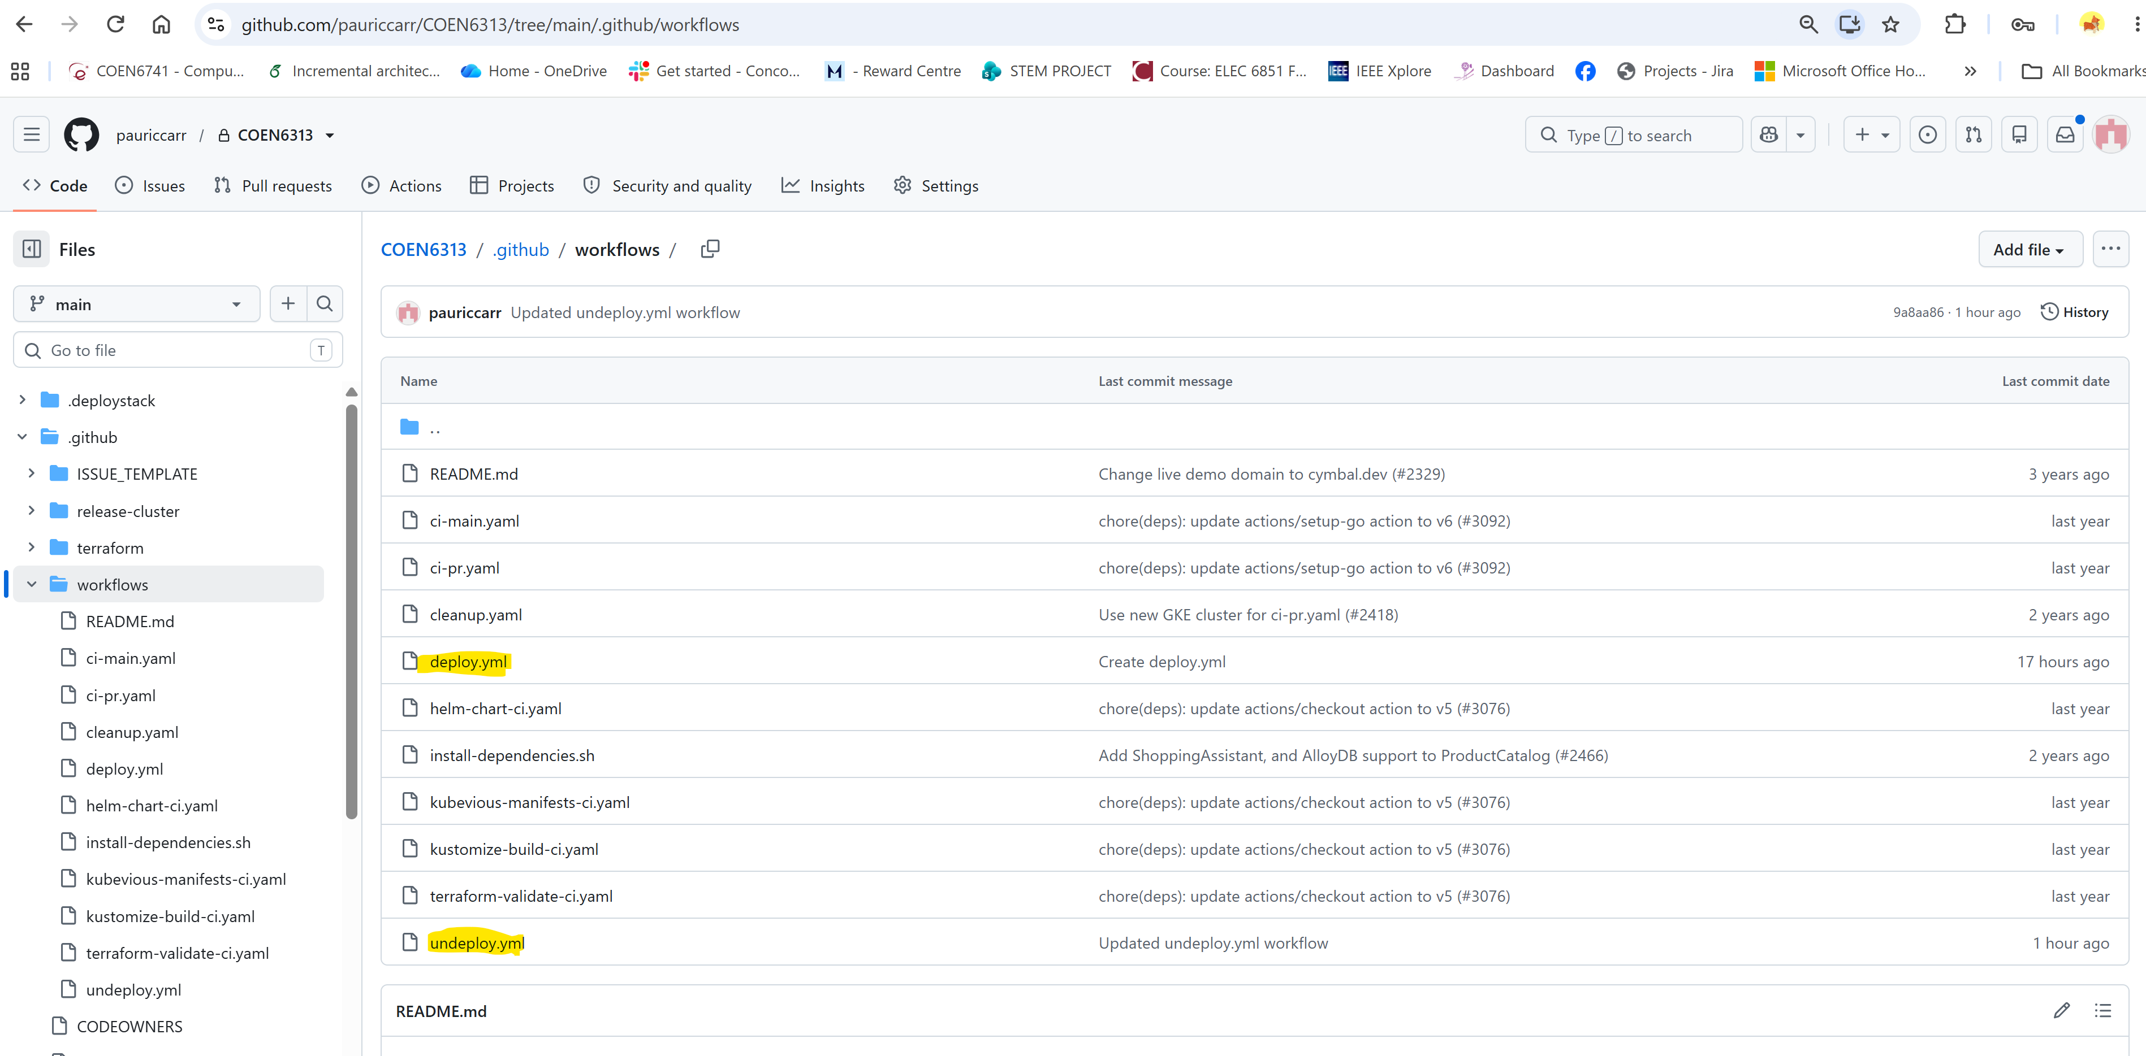

Now in GITHub Actions you will see Workflows:
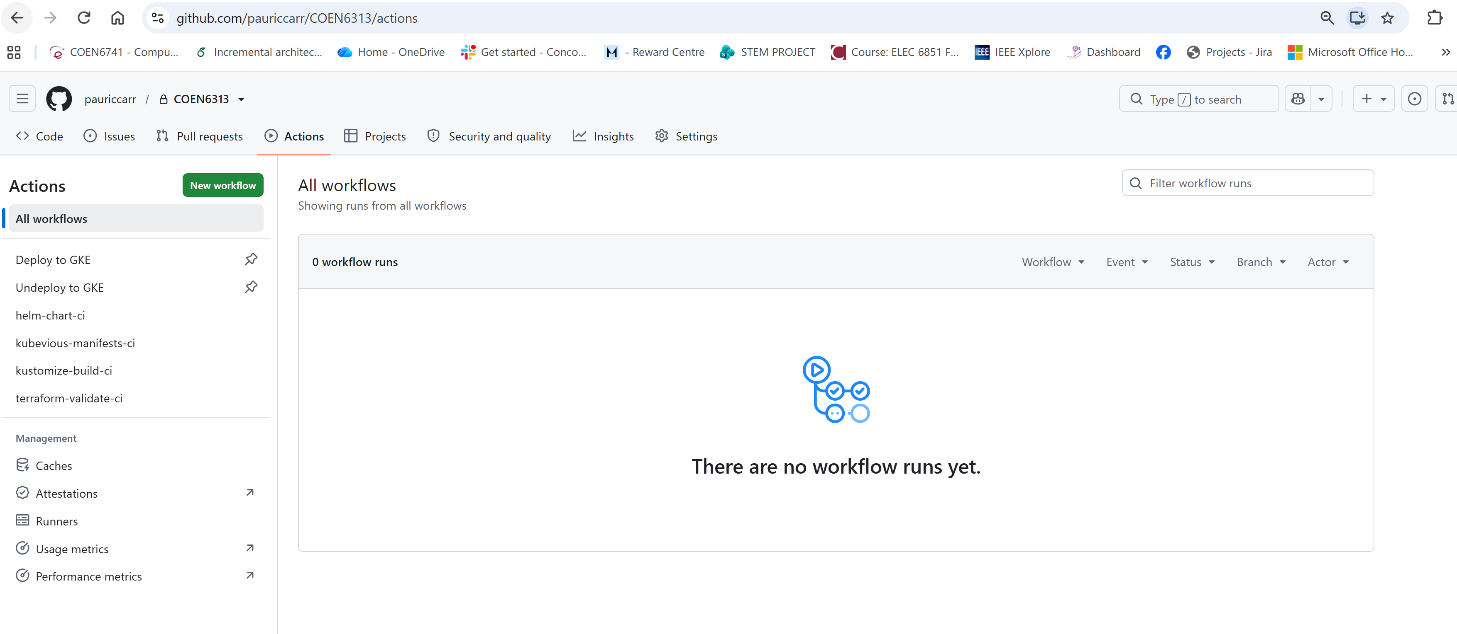

Or you can run in CLI - gh workflow run undeploy.yml --repo pauriccarr/COEN6313 or gh workflow run deploy.yml --repo pauriccarr/COEN6313

